1. Go to the website <https://www.parallels.com/products/desktop/>

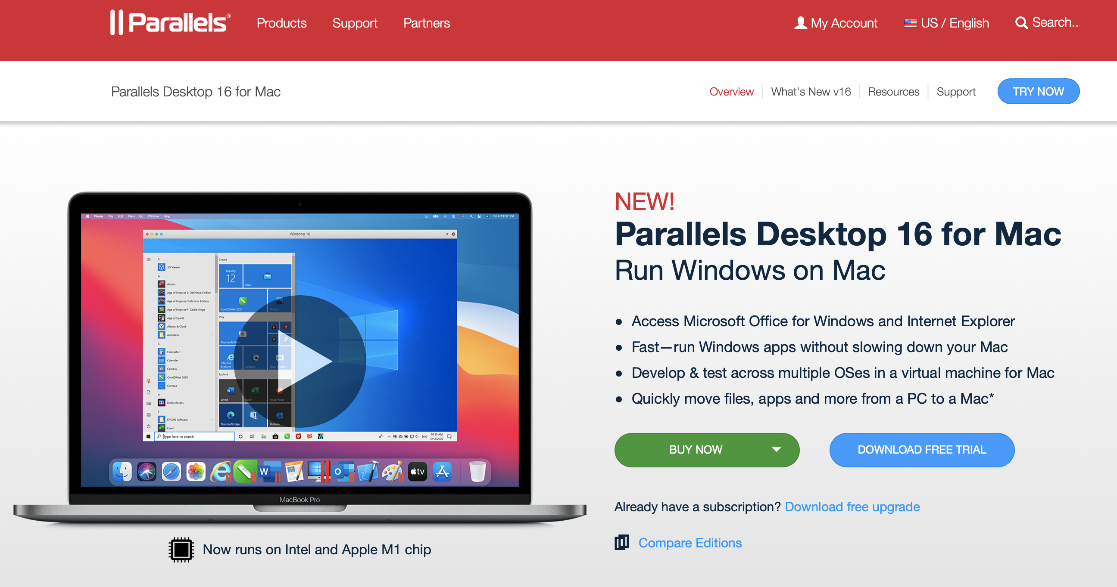

1. Click on Download free trial version. Note that this version is available for 14 days for free, which would be good for the next two weeks when we will use this tool. After you click on Download, this would take you to the Trial page.

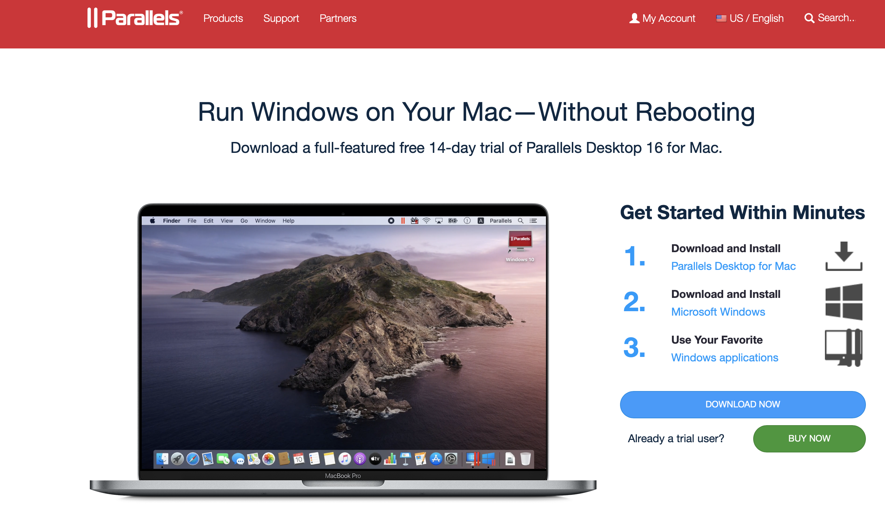

1. This is the trial page <https://www.parallels.com/welcome-trial/>

You can download the trial version from here directly.

Double Click on the downloaded file “Install Parallels Desktop.dmg”

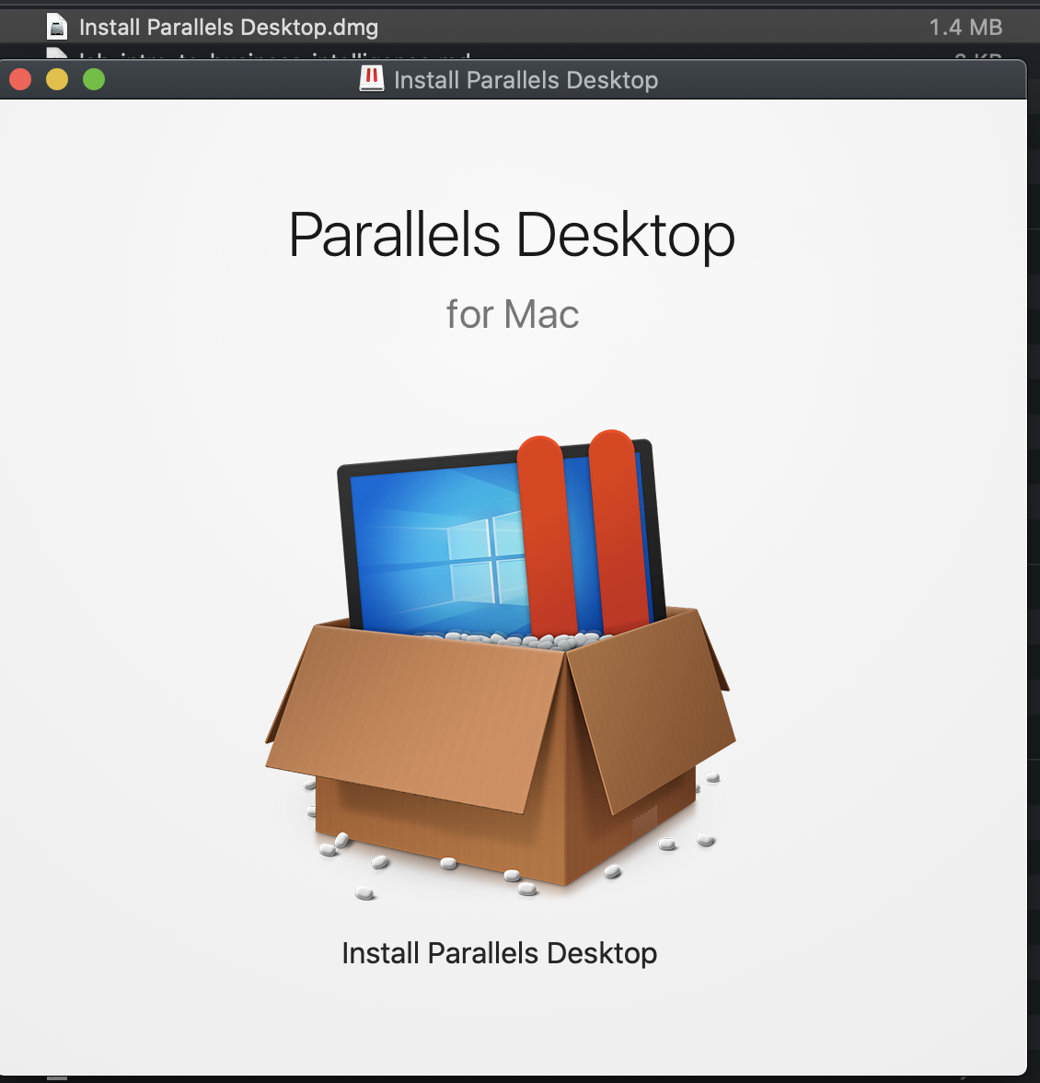

1. Double Click on “Install Parallels Desktop”

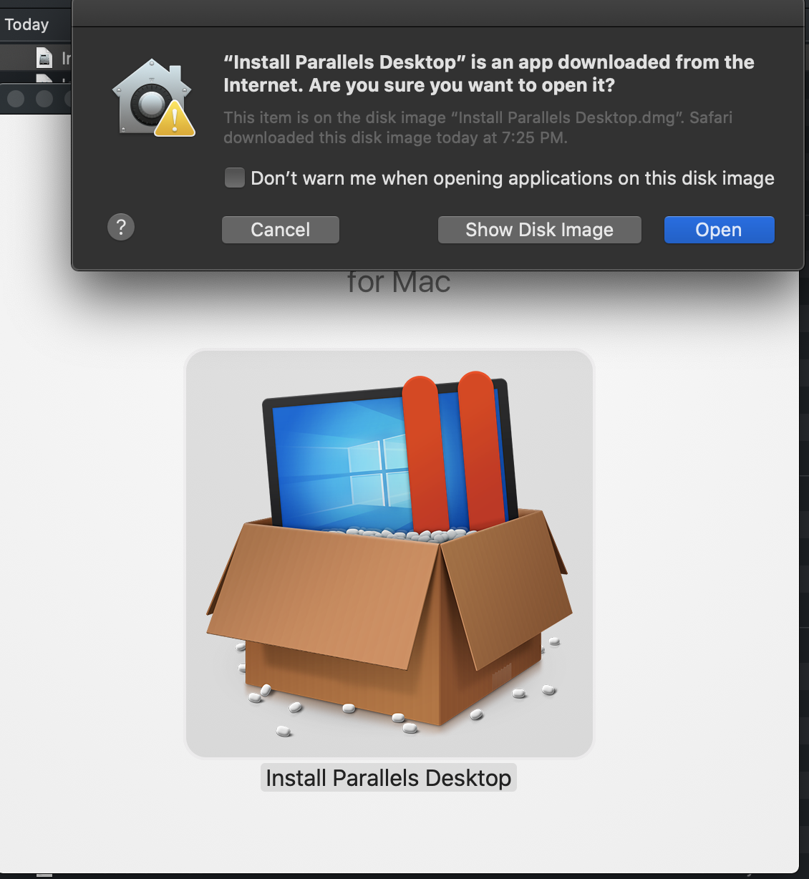

1. Click on Open and Allow

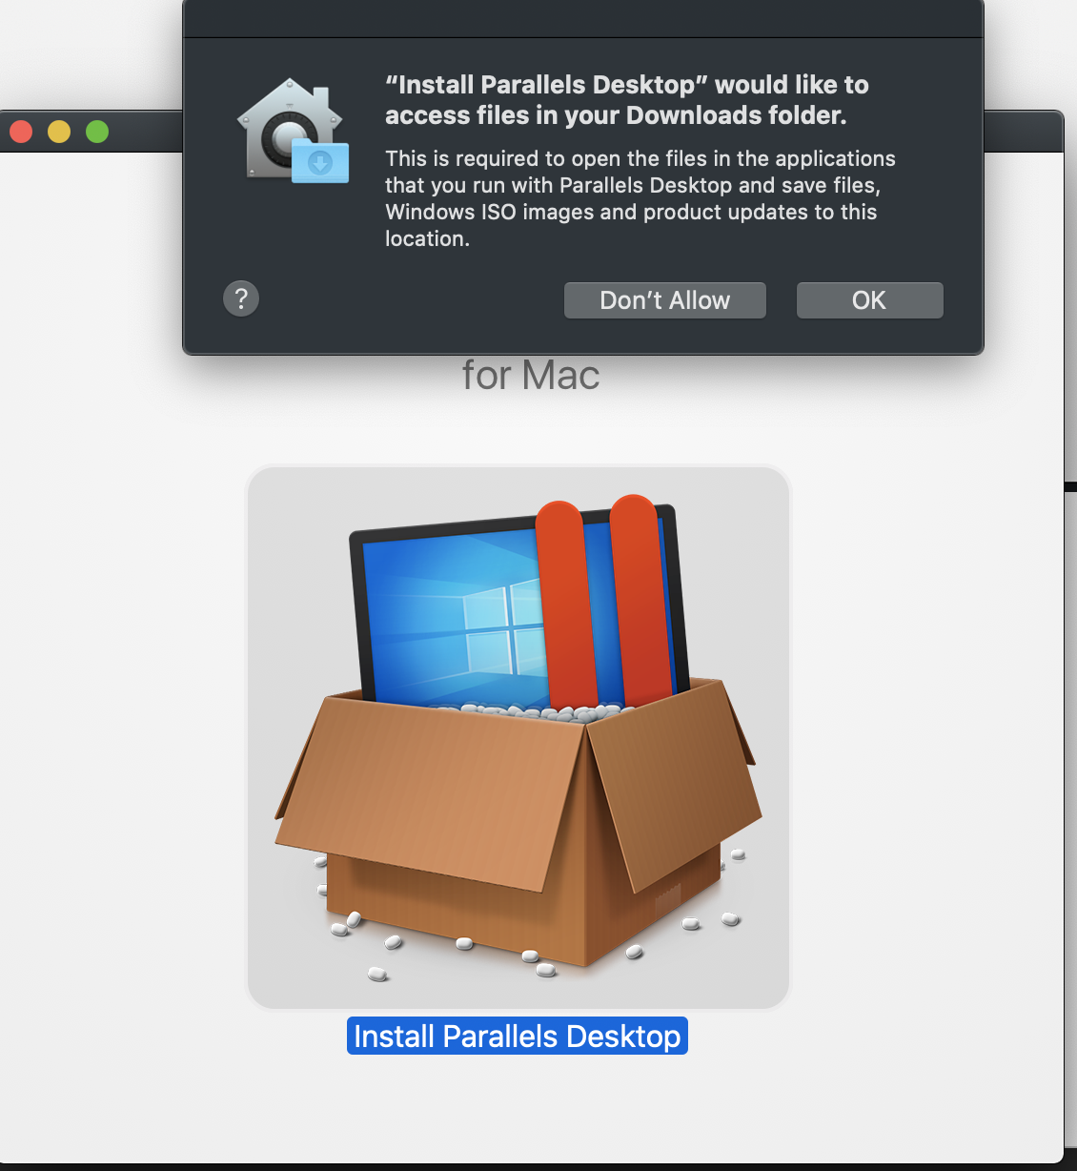

1. Now Click on Ok

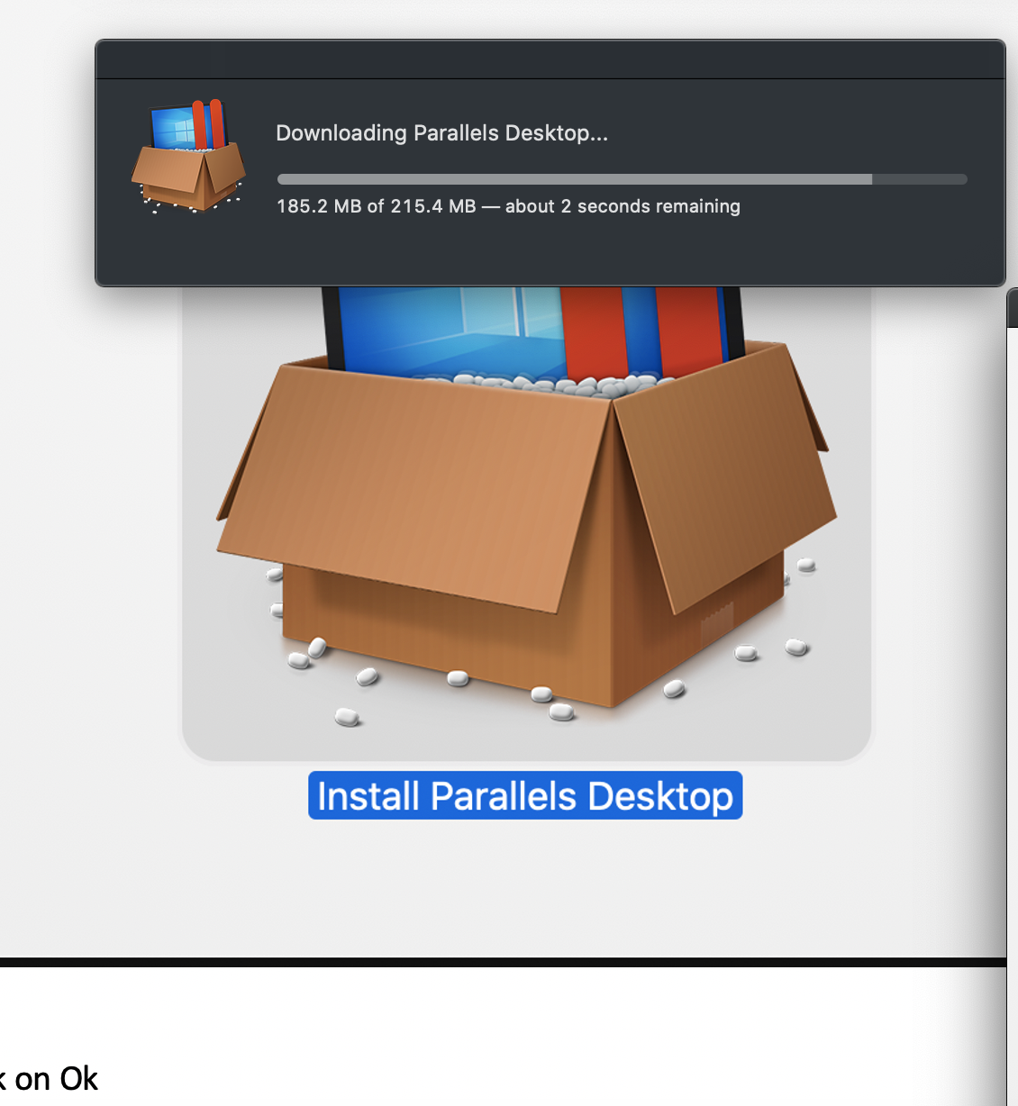

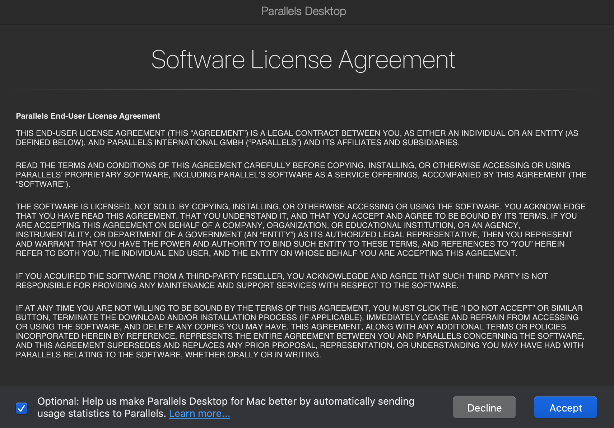

1. Enter your password

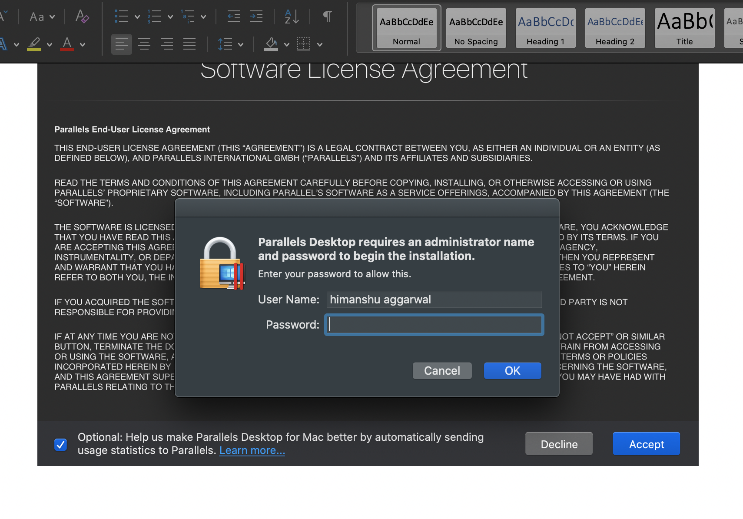

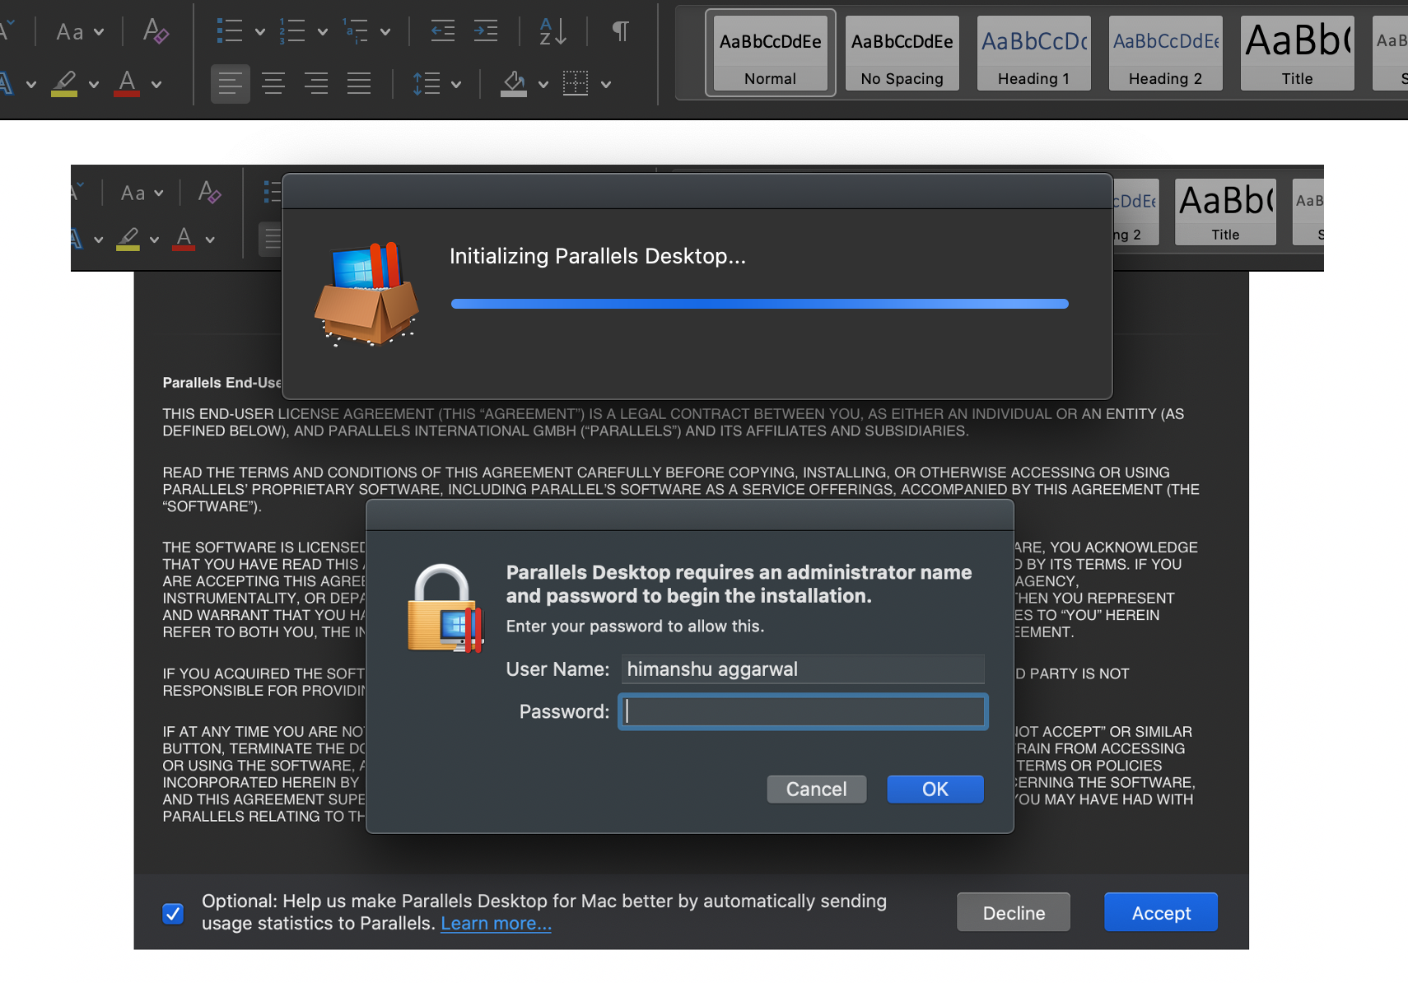

1. Edit Security preferences – as mentioned

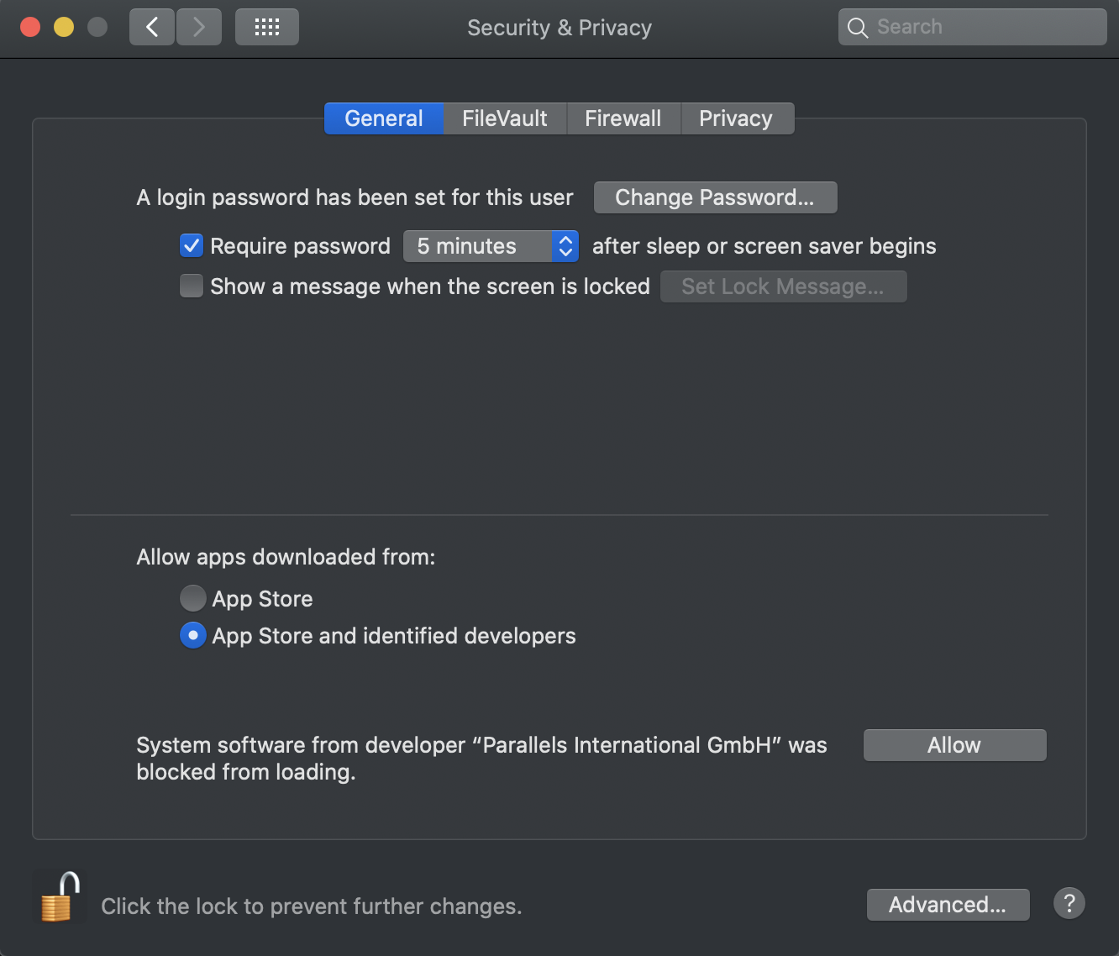

1. After clicking on Allow button on the right. Click on the lock again and close the window . GO back to Parallels window and follow the next steps

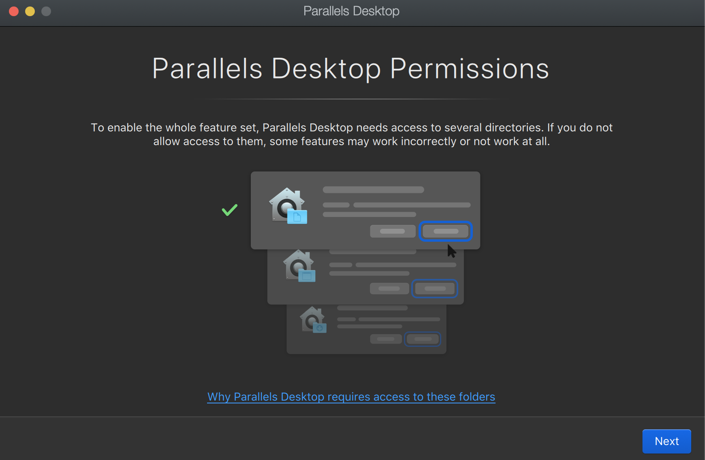

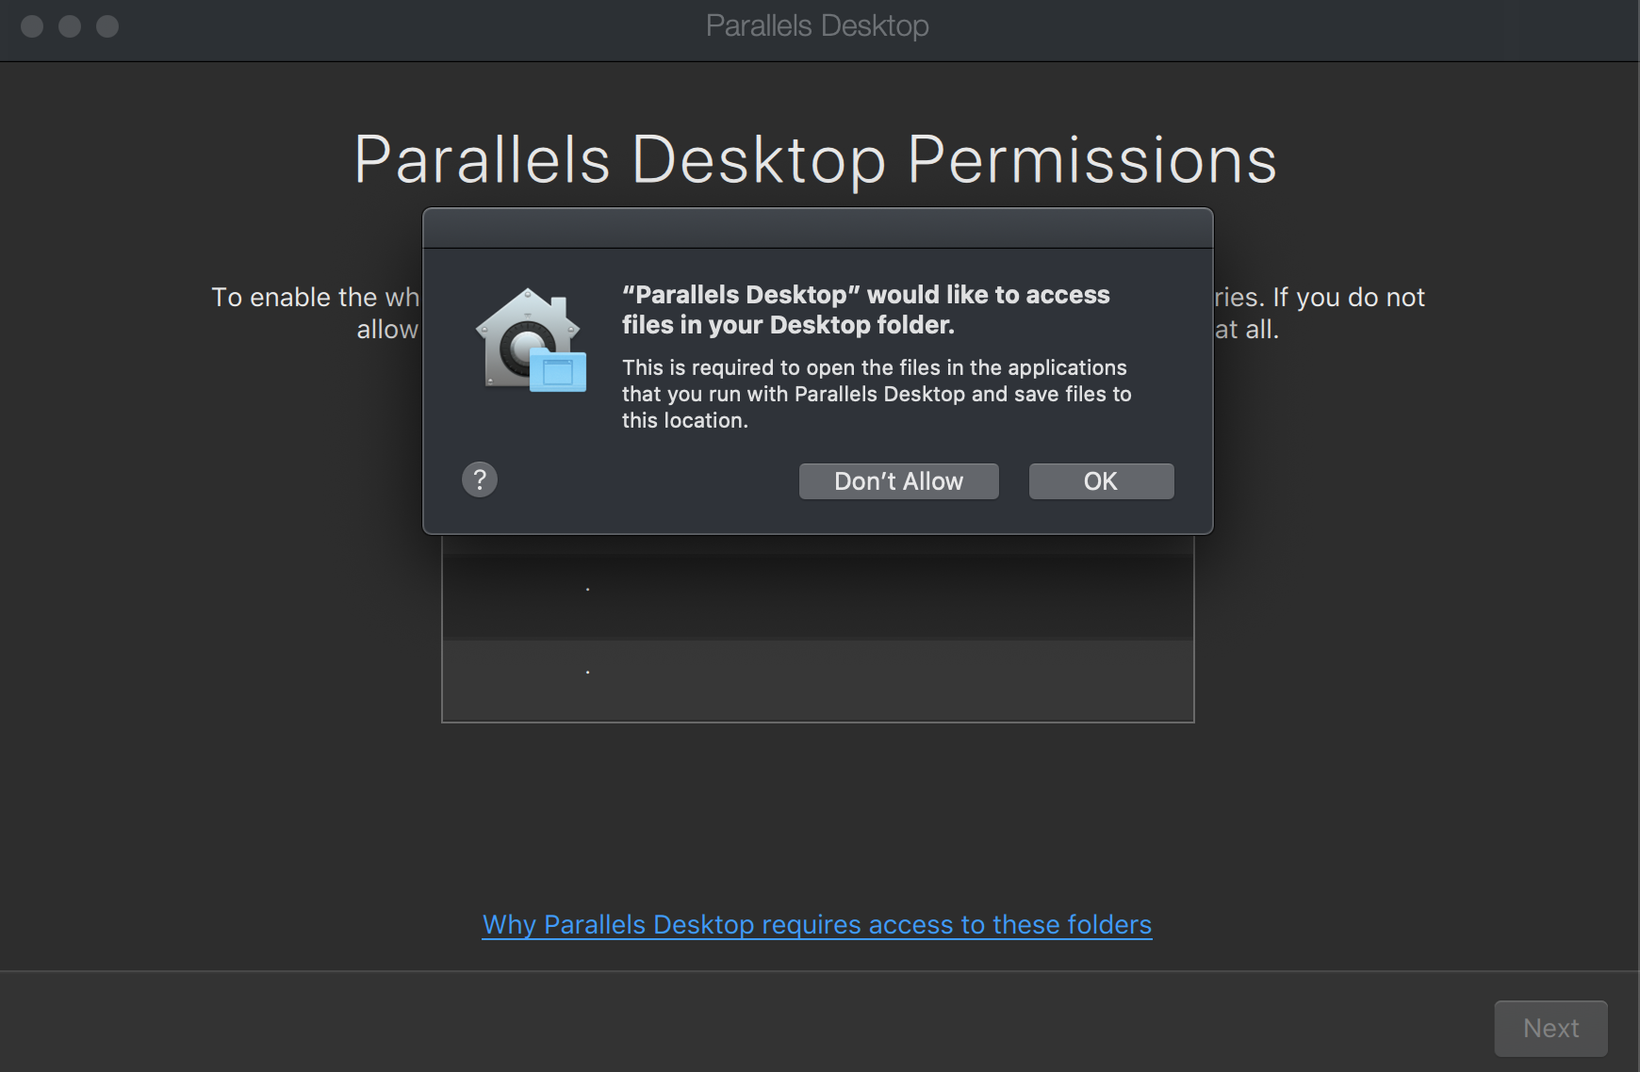

1. Next screen will automatically pop up – to install windows 10

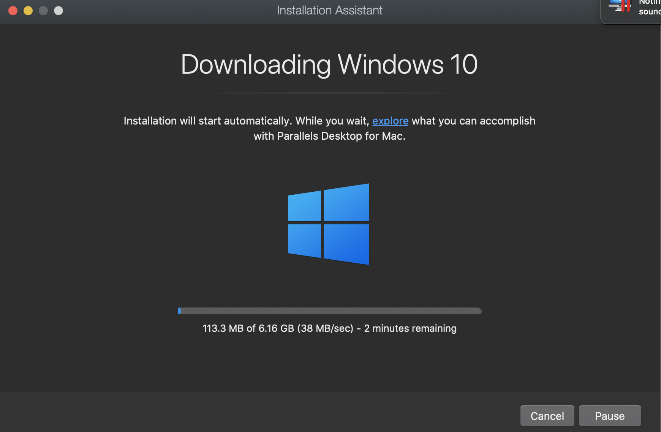

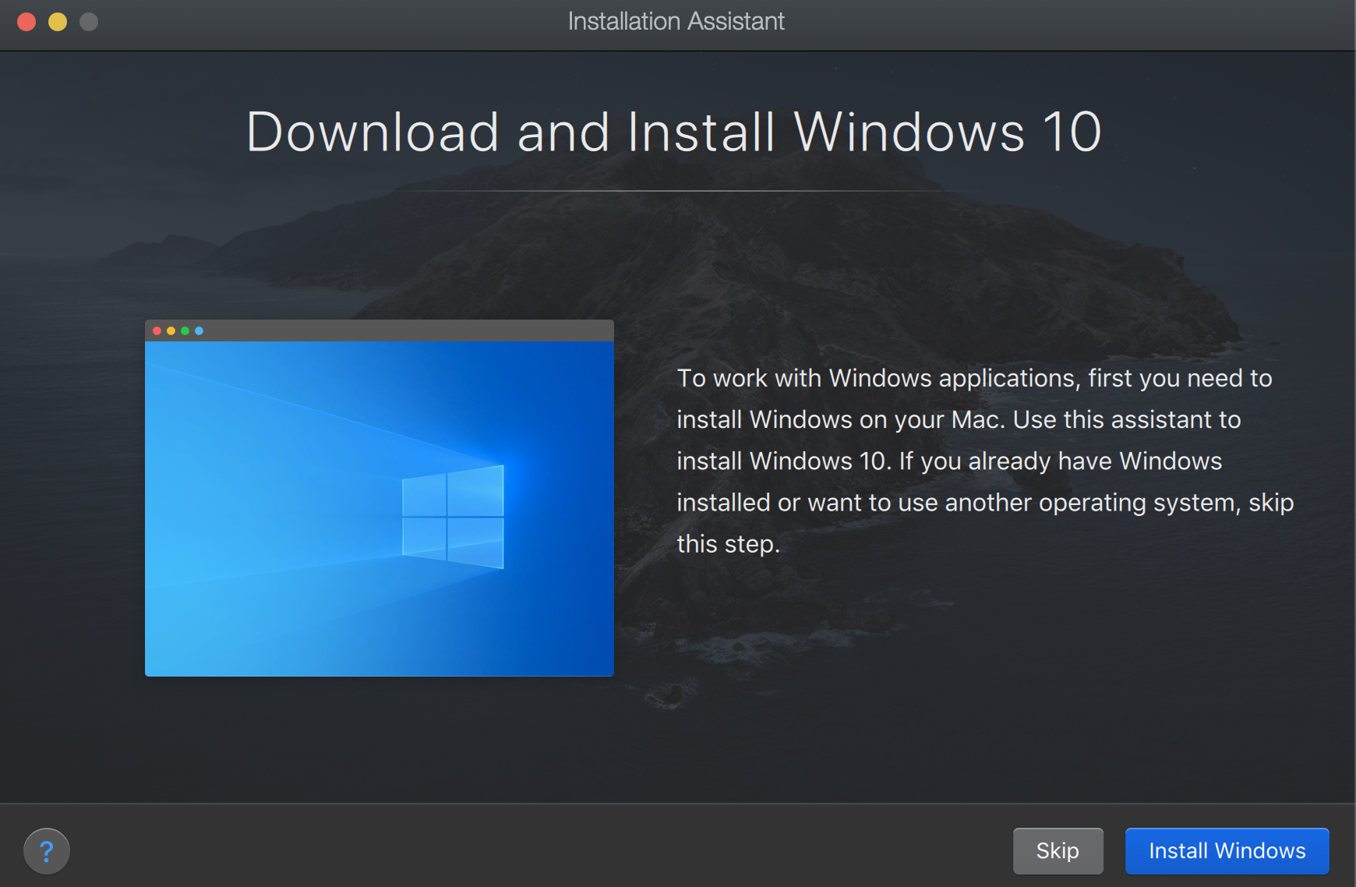

1. After downloading windows, follow the steps :

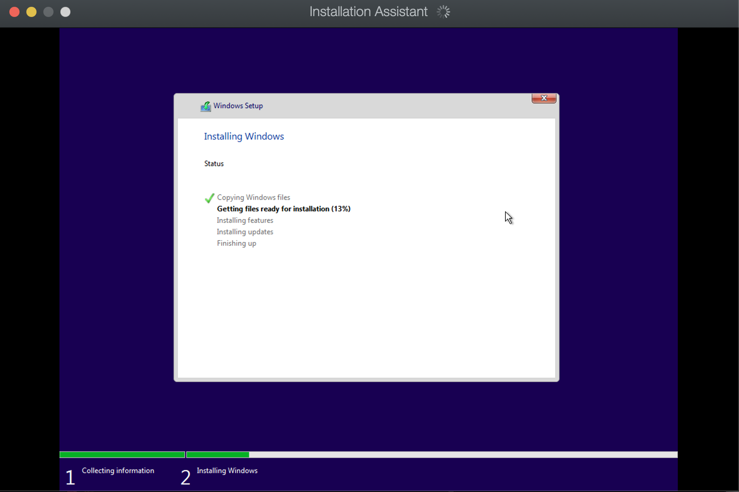

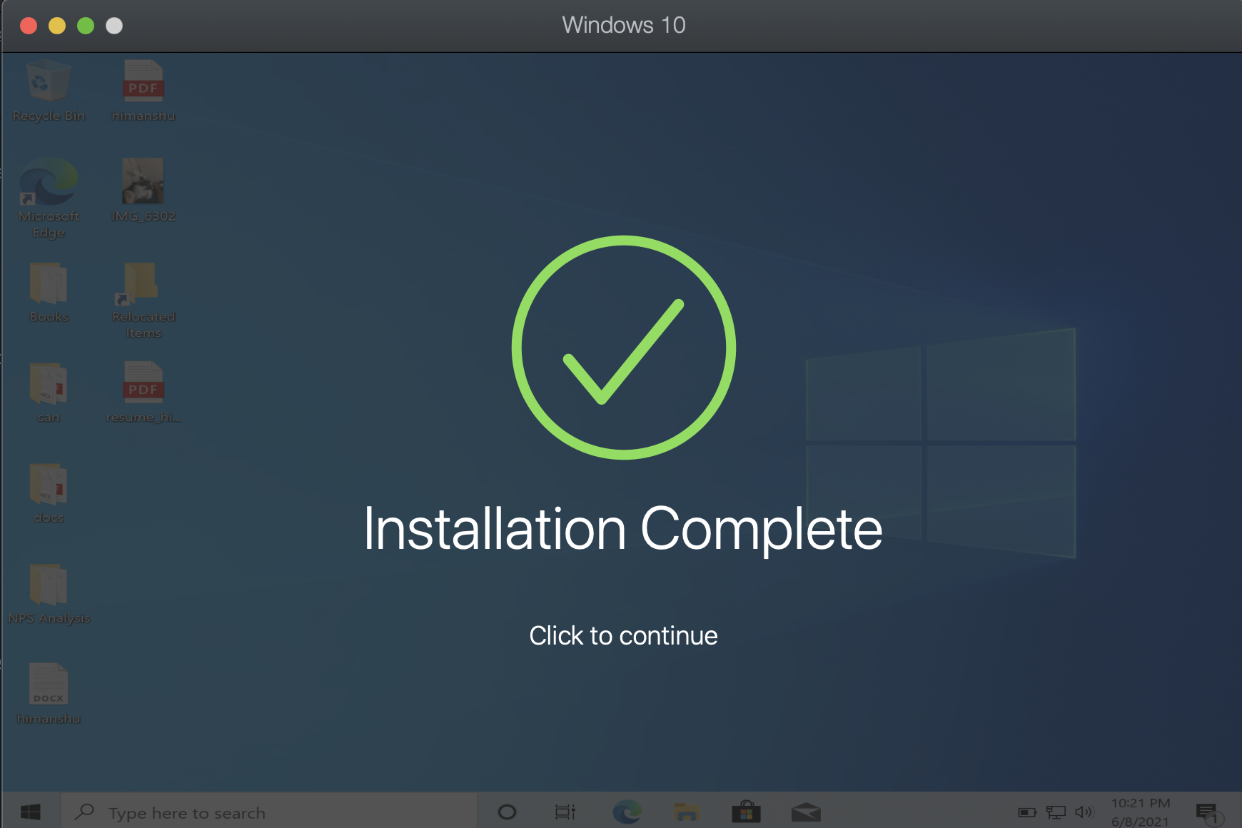

1. Click on continue. Set up an account using any of the options

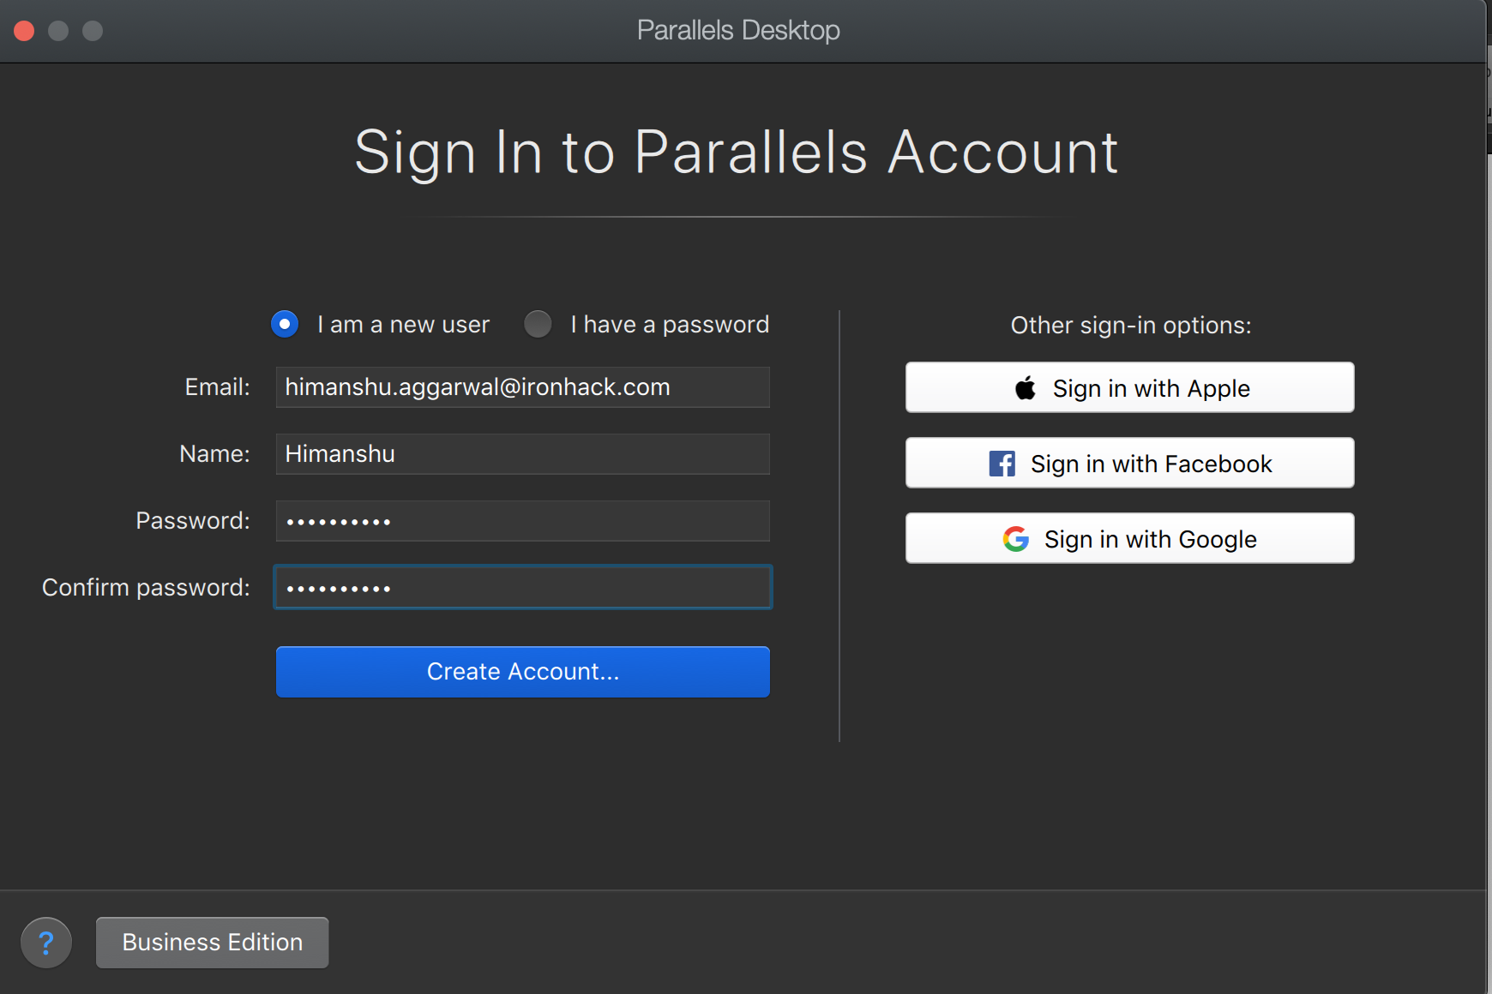

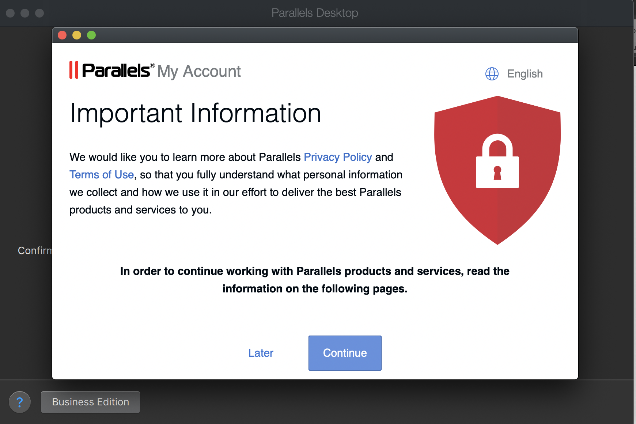

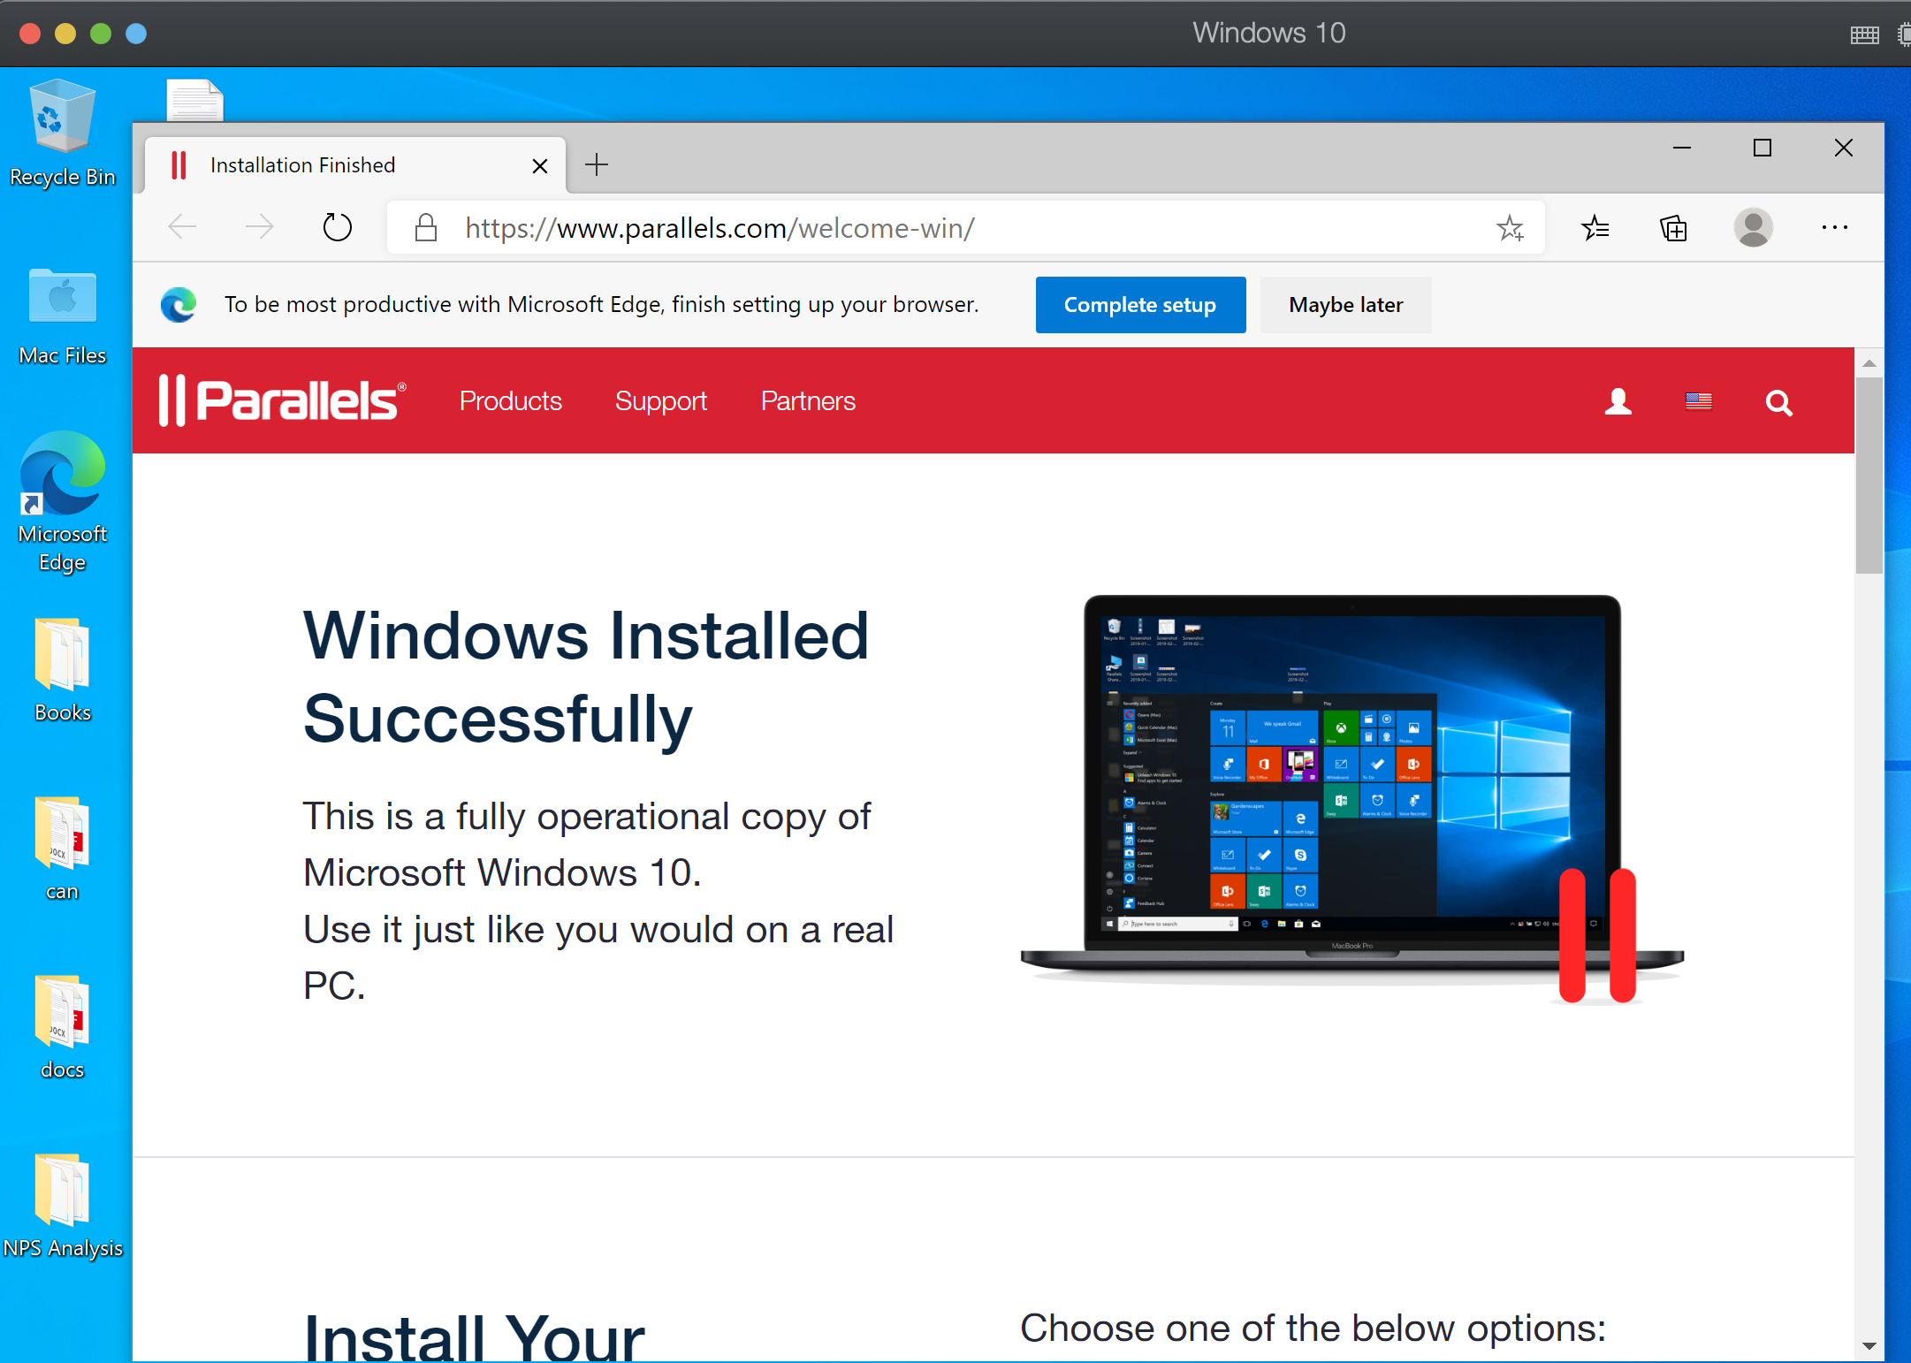

1. Now you can install Power BI. The instructions are mentioned in the below pages:
2. Go to your browser and search for “Download Power BI Desktop”. Scroll to the official link from Microsoft.com

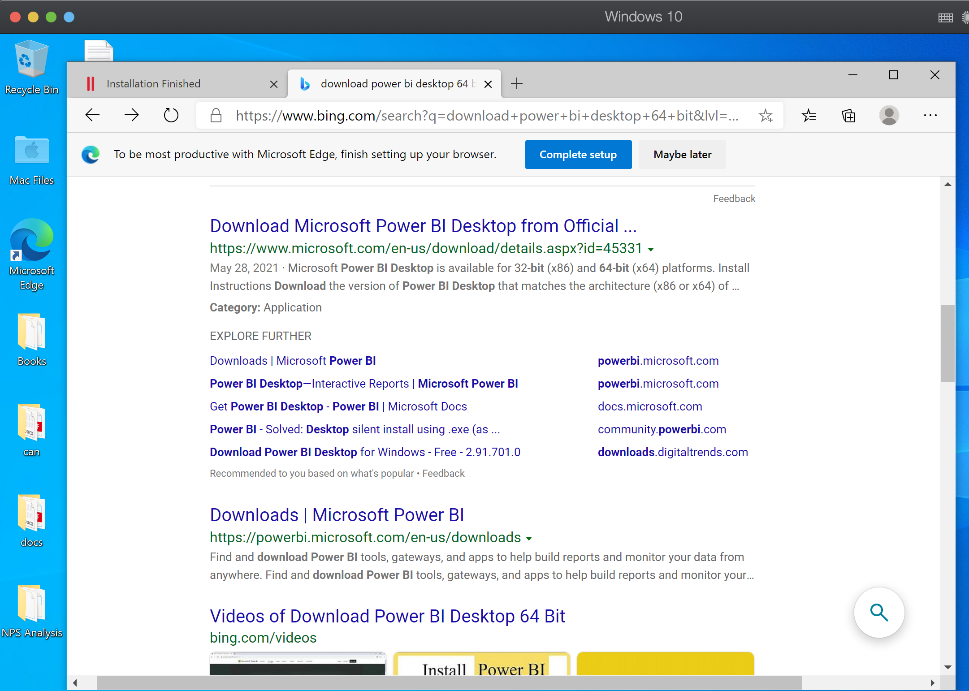

1. Scroll down on the page and check for the download instructions. It might direct you to another link <https://aka.ms/pbi.SingleInstaller> to download the latest version of Microsoft Power BI.

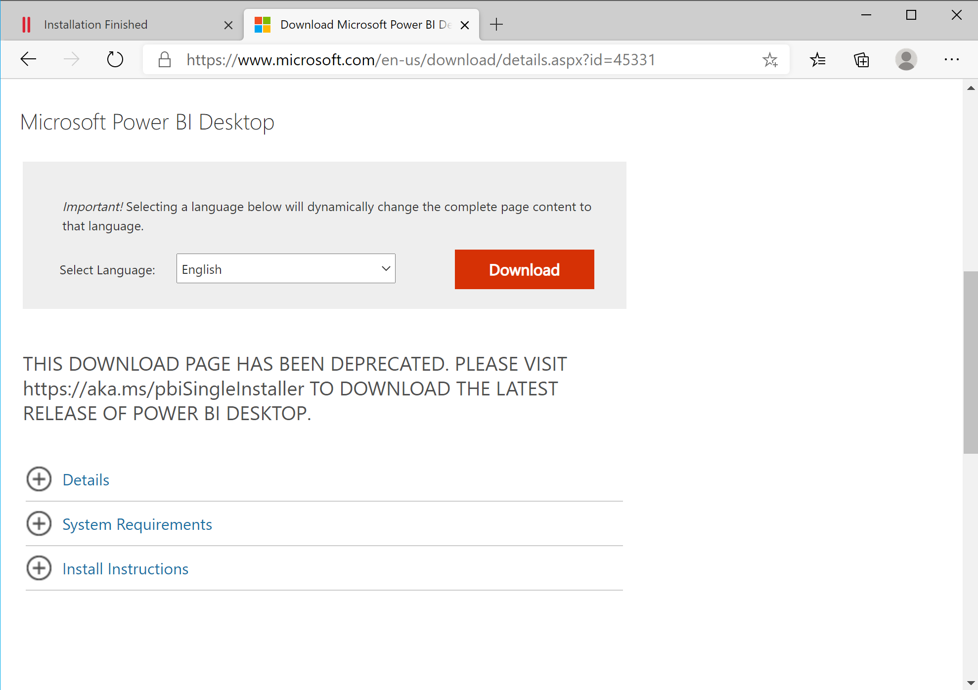



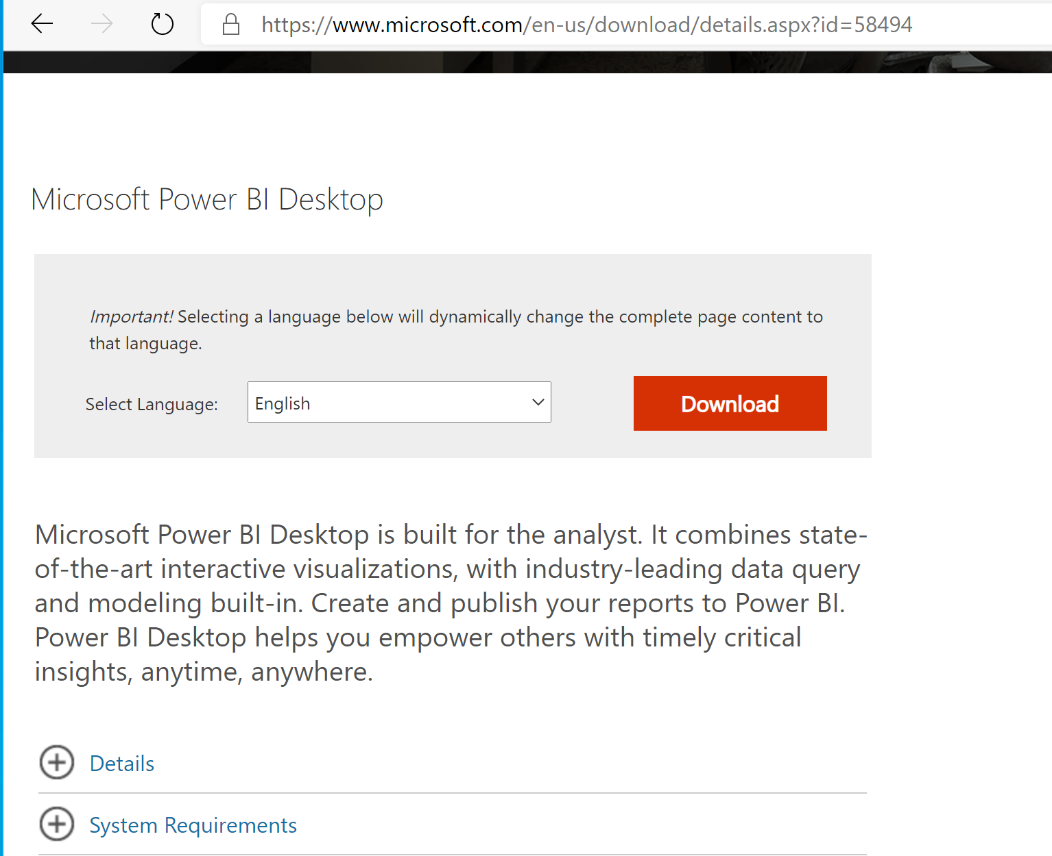

1. Choose the version of Power BI based on your laptop (32 bit or 64 bit version).

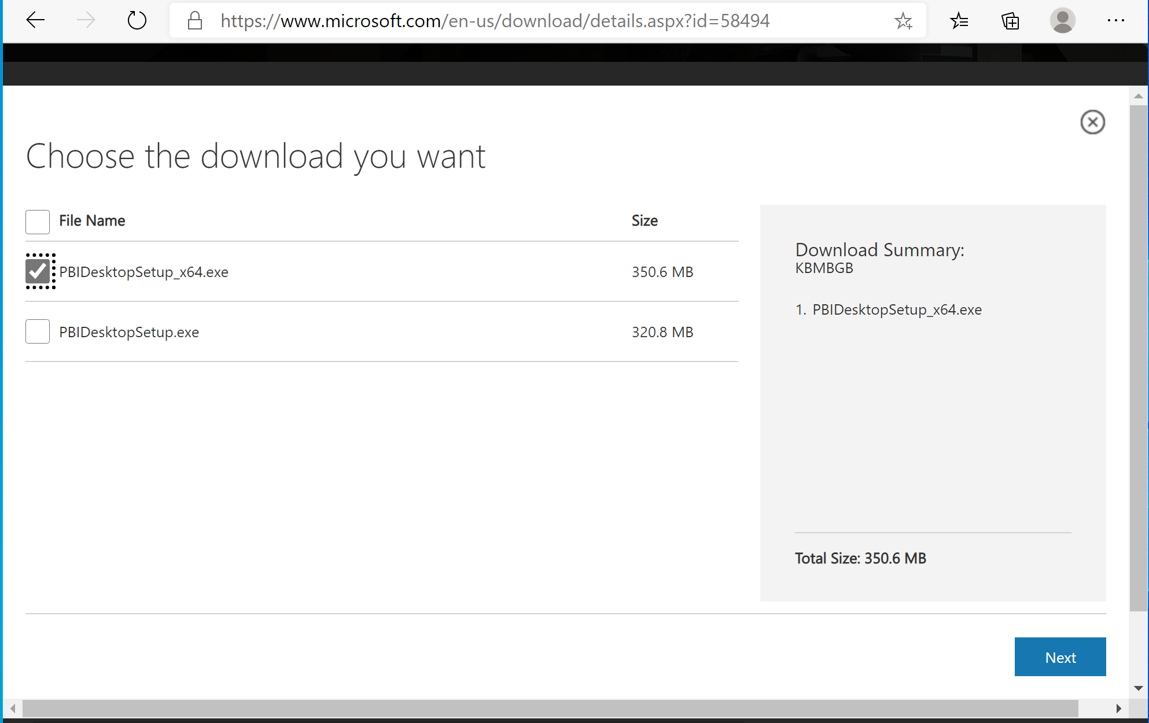

1. Download the exe file and start the installer

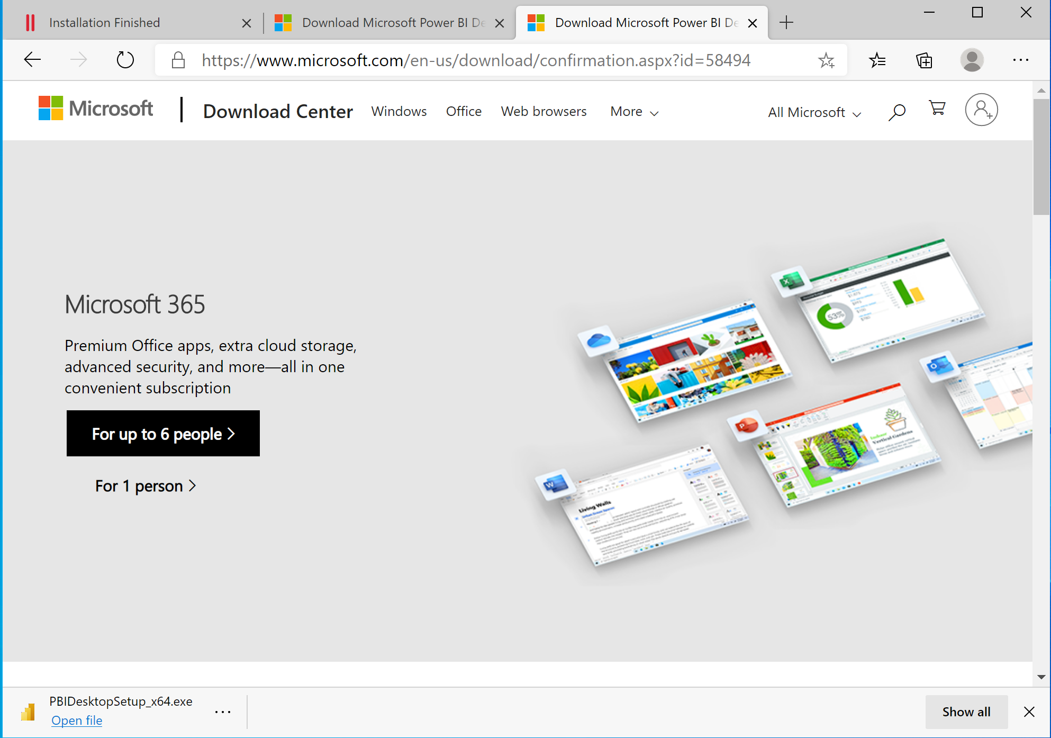

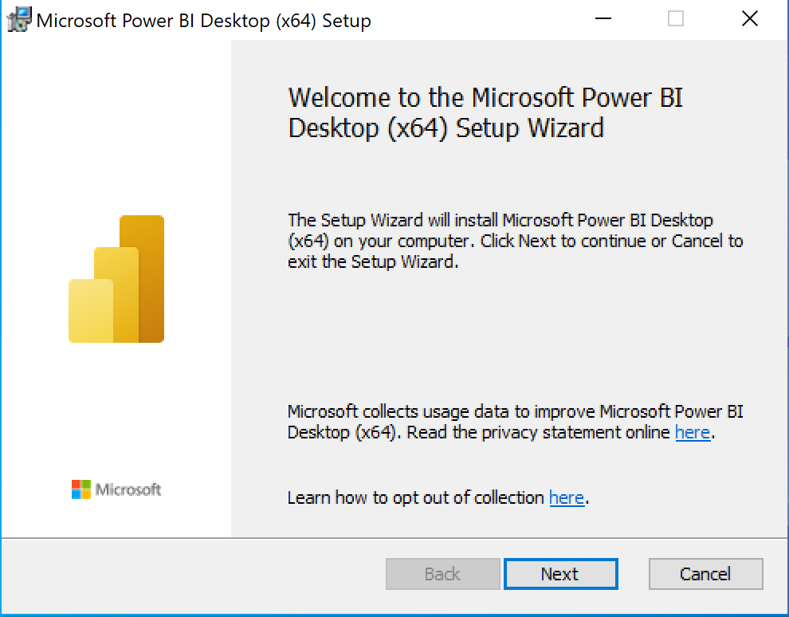

1. Follow the installation steps.

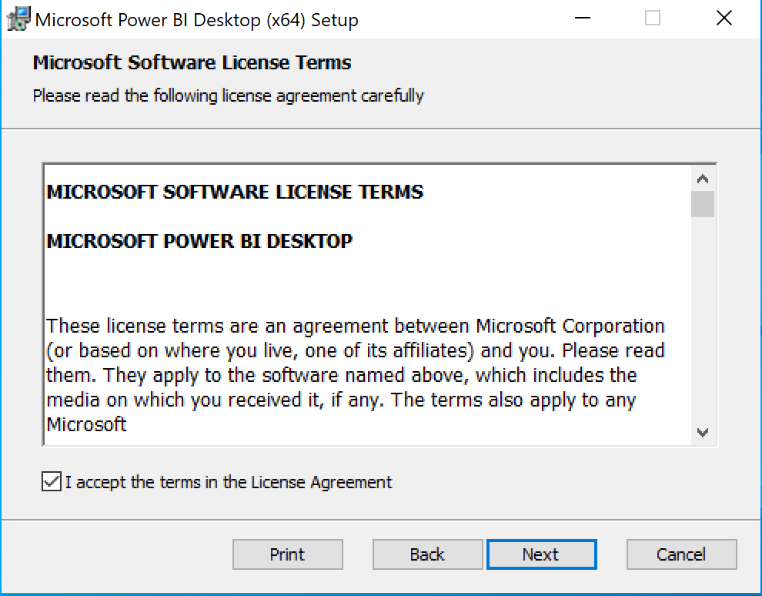

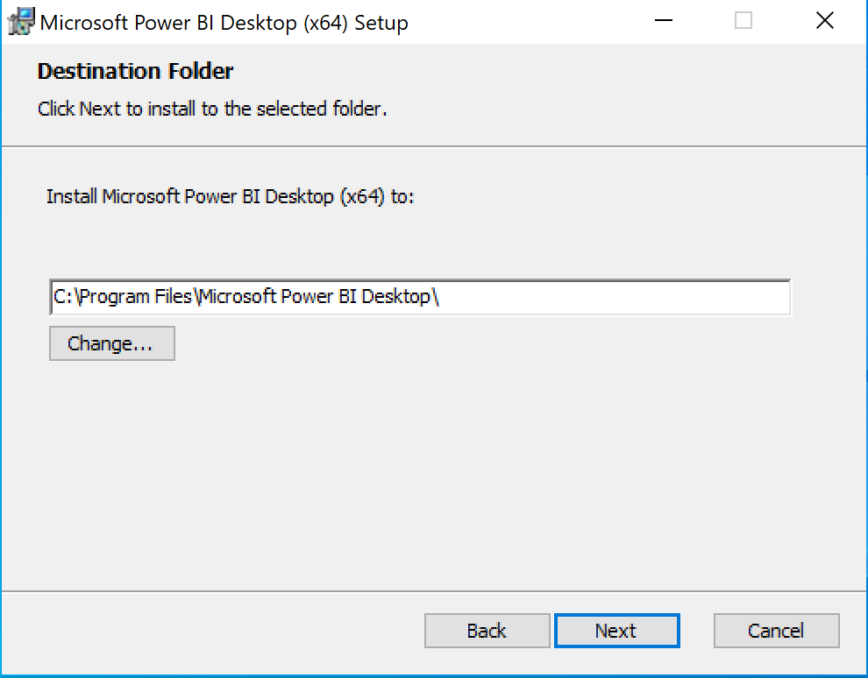

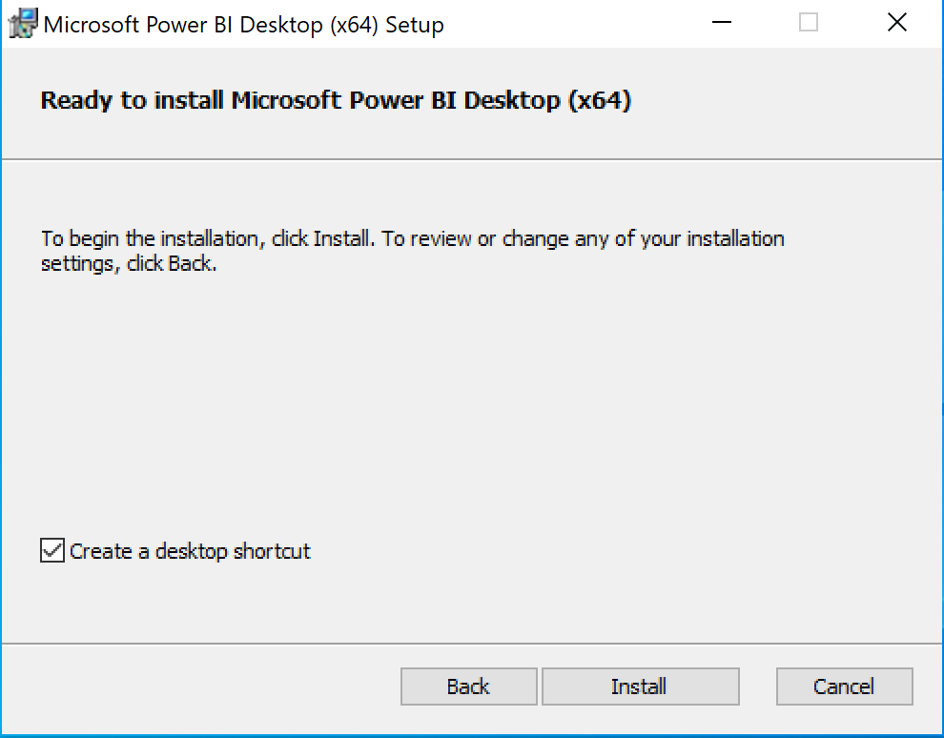

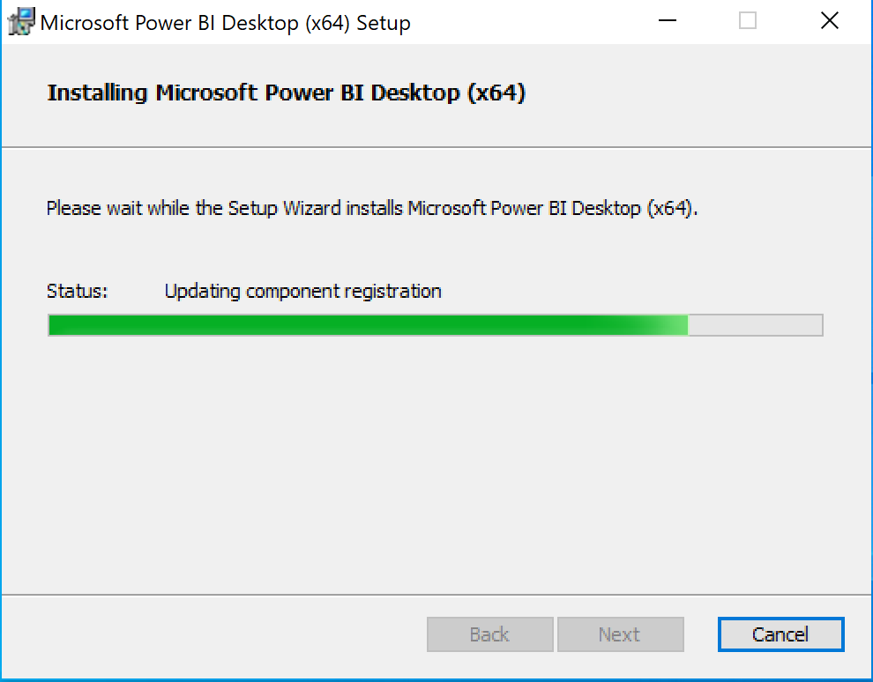

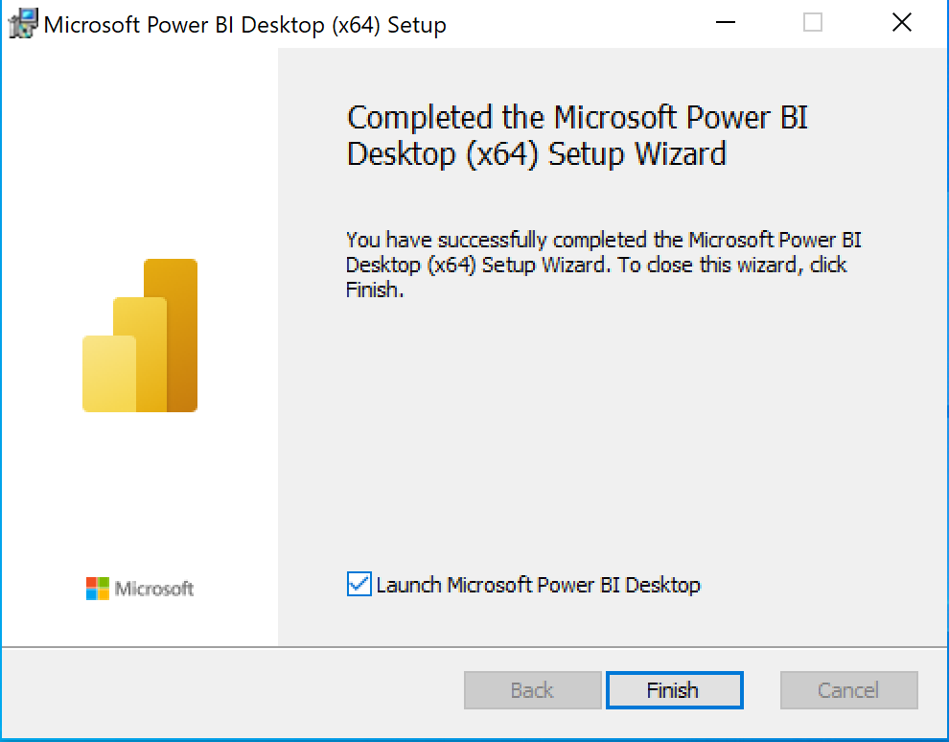

1. After you complete the installation successfully, this is how you would see the home screen. Close the dialog box.

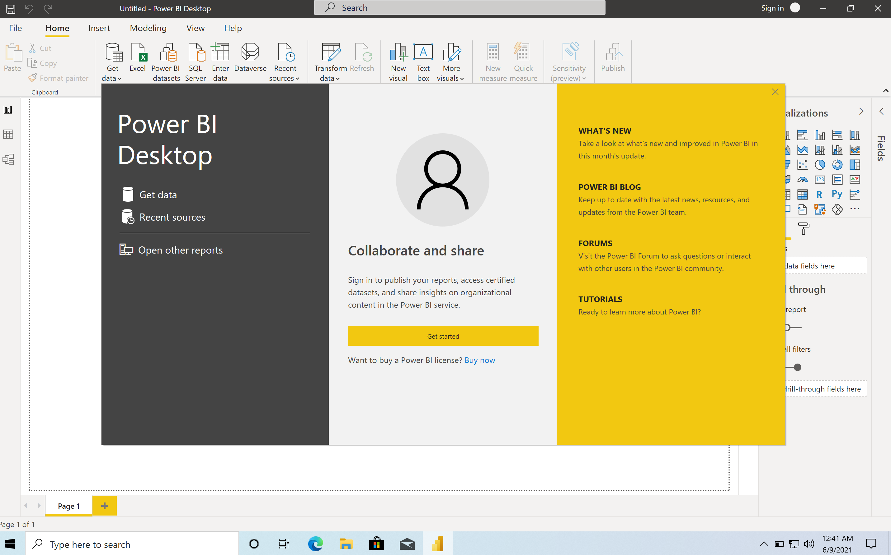

1. Sign In to Create an Account for the Power BI service (this step can be performed later as well)

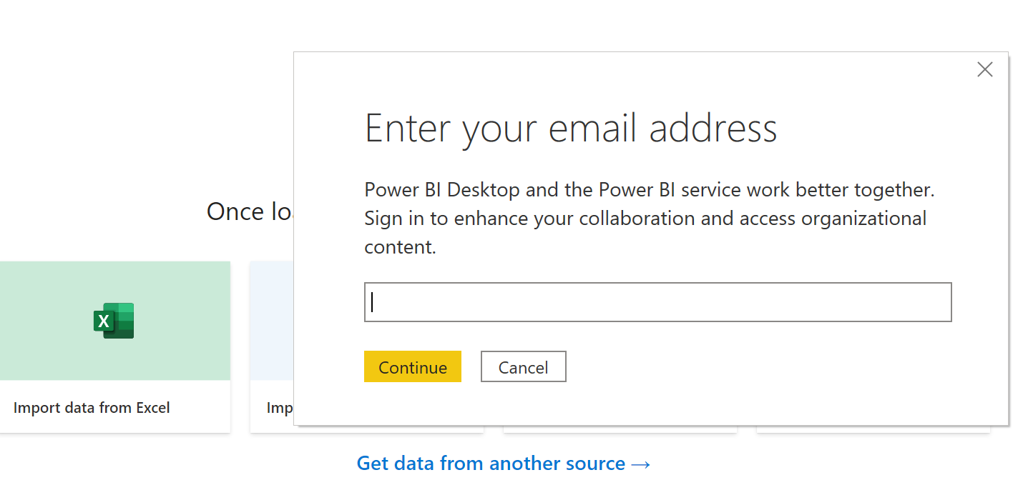

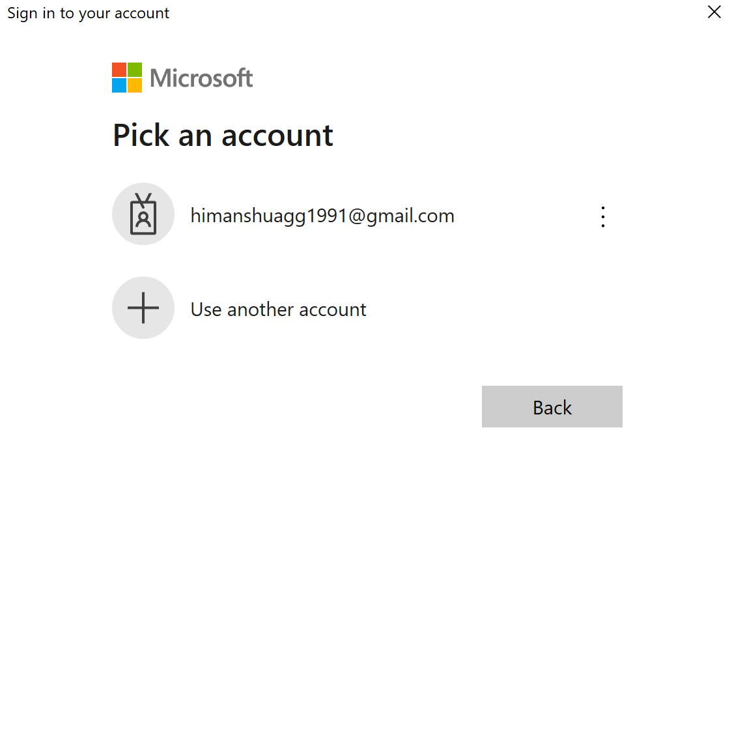

**Launch Application Now:**

1. **Search for the app using CMD+Spacebar or Go to launchpad to search for “Parallels Desktop”**

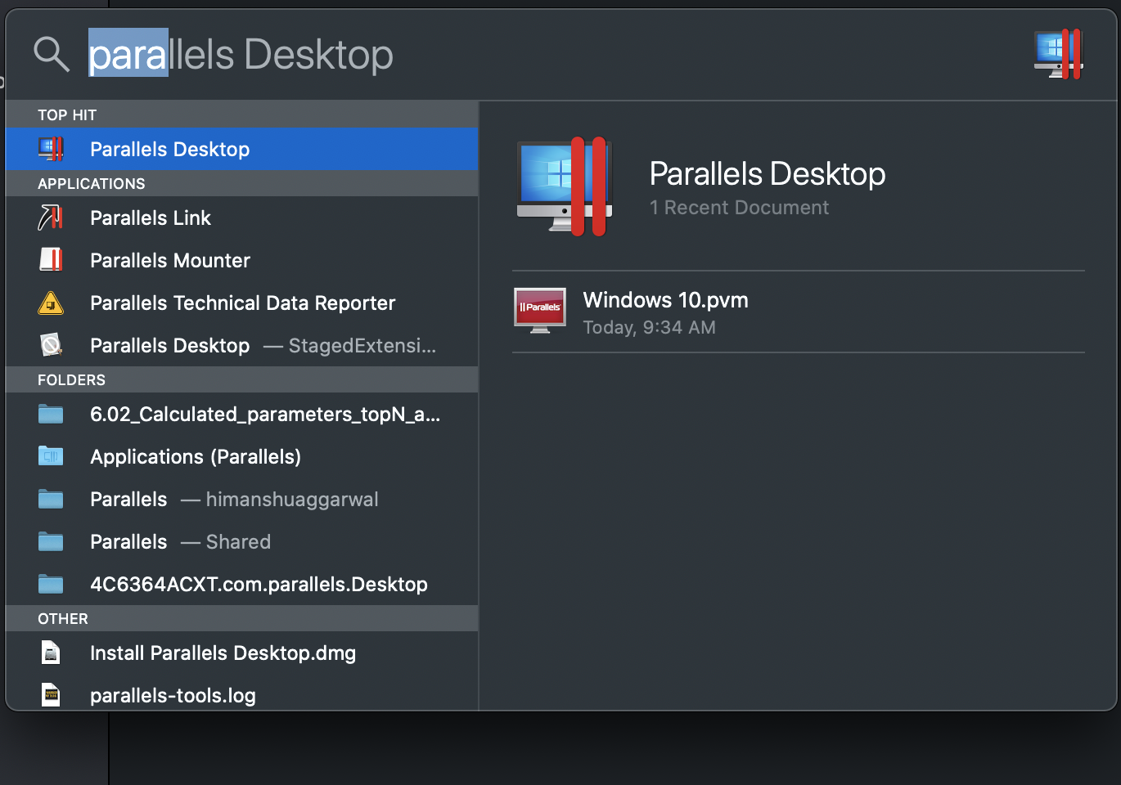

1. **This window pops up automatically**

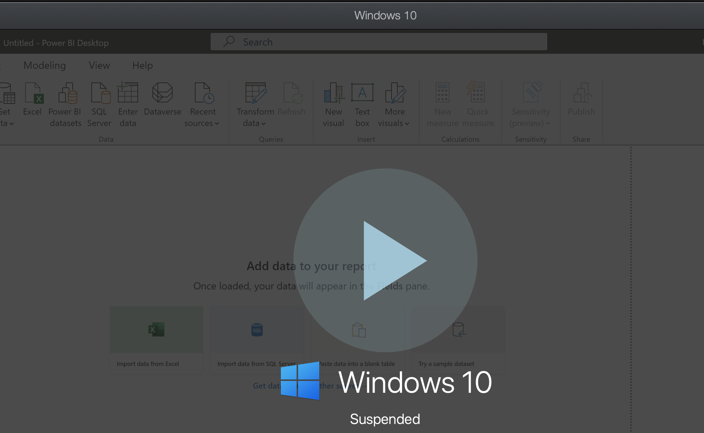

1. **Click on the play button and wait for the windows to start**

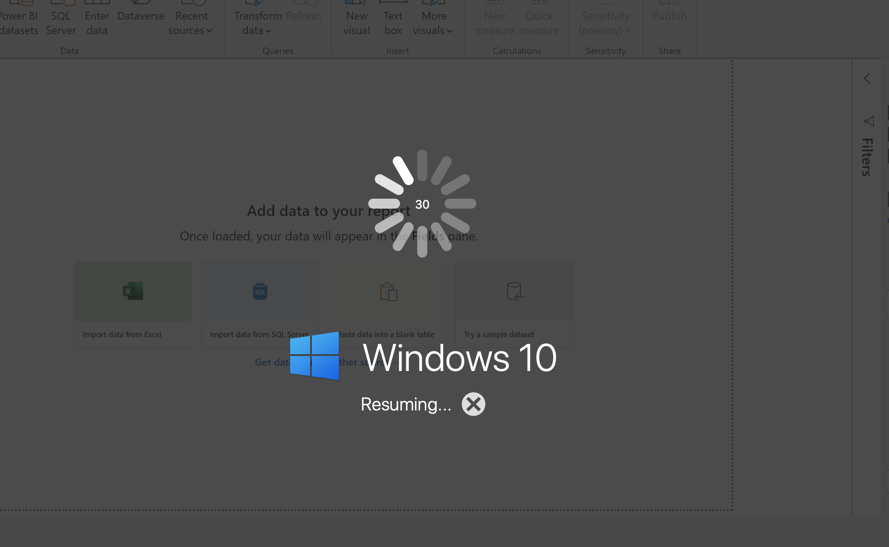

1. **Power BI will be launched from the same window where you left it off.**